Press Release: Lifestyle

PH to take a fresh direction in Maison&Objet Paris this year

- Select Manila FAME exhibitors slated to represent the country and captivate the global market in Maison&Objet Paris on September 6-10, 2019
Through the past participations of the Philippines in Maison&Objet Paris (M&O), the country continuously fascinates and excites the international lifestyle and design market. Year after year, Philippine products are garnering more and more interest from international buyers who go to M&O for its quality finds.
To maintain the momentum, it is essential to find new and fresh ways to present the Filipino design flare. Therefore, lead organizer Center for International Trade Expositions and Missions (CITEM), the export marketing and promotion arm of the Philippines’ Department of Trade and Industry (DTI), tapped Filipino designers who already have numerous ventures in trade shows abroad to develop new products to showcase in one of the best lifestyle platforms in Europe.
For this year, Rita Nazareno and Gabby Lichauco will lead select Philippine manufacturers and exporters as they champion the country through new product designs and concepts.
DesignPhilippines Presents “Kindred” at Maison&Objet 2019
Following the theme, “Kindred: A Design Collective,” the Philippine stand in Maison&Objet will be a showcase of collaboration and exquisite craftsmanship.

“We will focus on contemporary design and objects for this edition. As Filipinos are specialists in various design disciplines, we aim to harness this strength to catch the attention of M&O visitors this year,” shared Rita Nazareno, lead curator for the Philippine participation in Maison&Objet and Creative Director of S.C. Vizcarra and Zacarias 1925.

Rita Nazareno is one of the esteemed exhibitors of Manila FAME, the Philippines’ premiere international design and lifestyle show. Her brands Zacarias 1925 and S.C. Vizcarra have been a part of the show for many fruitful decades.

M&O Paris 2019 will be Rita’s first foray as lead curator and product developer for the Philippine participation. For this venture, she will be channeling her over a decade of experience and success in overseas tradeshows such as Premiere Class Tuileries, Pitti, Salone and M&O Paris and Singapore with her homegrown brand. “I have been a part of many international events for my brand; so, this time, I look forward to curating the products of a fabulous group of exhibitors with similar sensibilities,” shared Rita.

The Philippine team will, likewise, present an interesting collection of products fashioned from the collaborations among participating exhibitors.

“HaloHalo and E. Murio, both new to M&O, will have a few pieces that they’ve collaborated on and that we are excited about. Vito Selma will release a new piece with a fantastic texture that we

can’t wait to show. JB Woodcraft is also doing some very contemporary carvings that I am looking

forward to. The eclectic artist behind “Garapata,” Dex Fernandez, has worked with both South Sea Veneer and Zacarias 1925,” Rita excitedly shared. “Garapata” is a character based on the fleas that once took over the designer’s childhood home. It symbolizes the artist’s direct and simpler approach to street art.

“I am thrilled that Gabby Lichauco and I are partnering in putting together Kindred: A Design Collective for the Philippine participation in M&O. We have worked closely with the manufacturers to bring a compelling collection and mark our edge once again in the field of arts and design,” Rita added.

“The combined expertise of Rita and Gabby will surely give a different touch to our presentation in the upcoming M&O show. I am optimistic that we will further enhance our niche in the EU market as we showcase the evolving artistry and creativity of Philippine designers who create exquisite product lines for the world market,” shared CITEM Executive Director Pauline Suaco-Juan.

Other exhibitors joining this year are CSM Philippines, Schema, Finali, Weave Manila, Nature’s Legacy, CDO Handmade Paper and Tali Handmade. Catch them at Hall 5A, Unique and Eclectic Signature, Booths M40 N39.

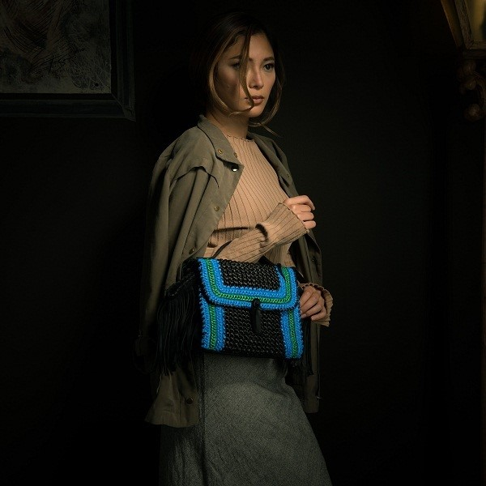
Sari Bag by Tali Handmade is one of the products to excite Maison&Objet Paris 2019.

The Philippine delegation in M&O is also part of the 70th edition of the Manila FAME, the longest-running event on design and lifestyle in the Philippines. It is slated on October 17-19, 2019, at the World Trade Center Metro Manila.

As a melting pot of Filipino creativity, Manila FAME is the Philippines’ premier sourcing destination for high-quality artisanal products. It serves as a cultivating ground and springboard for innovative, top-of-the-line Philippine products and designers to break through key international markets. Visit www.manilafame.com for more information.
###

Tel: 831-2201 local 253
Email: rabeledo@citem.com.ph
Twitter: @CITEMPh
Facebook: @DTI.CITEM

