Photo Release: Business

PH electronic export edge featured in Germany

- The Philippine delegation has featured the country’s strong capabilities in the field of product design, product development, manufacturing services and strategic investment areas, among other market opportunities, in one of the world’s biggest electronics event.

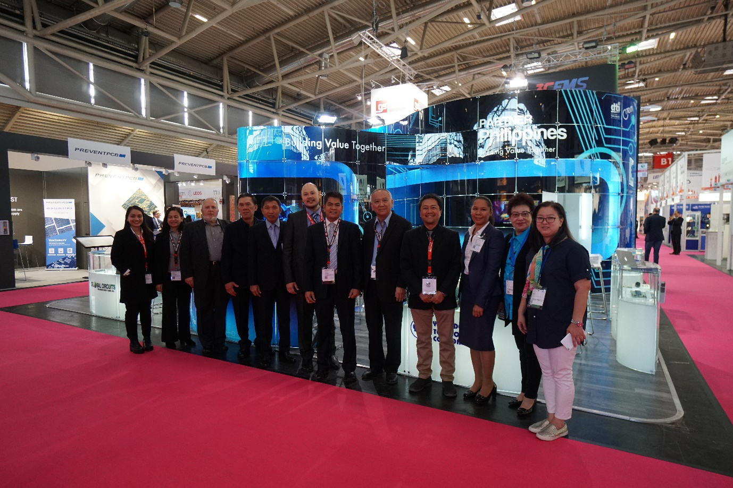
The Philippine delegation (from left to right): Giselle Erese of CITEM, Lanie Dormiendo of BOI - Europe, Middle East & Africa Division, Jurgen Mannzen of Global Circuit Sourcing Solutions, Joey Palma of Global Circuit Sourcing Solutions, Edgardo Etac of Tsukiden Electronics Philippines, Earl Qua of Ionics EMS, Inc., Valerio Carandang of Ionics EMS, Inc., Alex Sy of Yongden Technology, Elmer Lapeña of Testech Group, Dhanistha Panyasak of Testech Group, Mila Sy of Yongden Technology and Maribelle Uy of Yongden Technology
In a bid to further expand the Philippine electronic exports, the Department of Trade and Industry, through the Center for International Trade Expositions and Missions (DTI-CITEM), showcased the country’s competitive advantage in the global electronics value chain in its comeback participation after 20 years in Electronica 2018 in Munich, Germany, last November 13 to 16.

Existing for more than 50 years, Electronica is the world’s leading international trade fair for electronic components, systems, applications and other innovative solutions, such as smart homes and electronic cars. For 2018, more than 3,100 exhibitors from over 50 countries gathered to network with around 80,000 visitors from over 80 countries from around the world.

During the four-day event, the Philippine delegation has featured the country’s strong capabilities in the field of product design, product development, manufacturing services and strategic investment areas, among other market opportunities.

“Our much-awaited return to Electronica has been a success since the participating companies were able to introduce new products, tap new markets, meet new buyers and explore partnerships with foreign counterparts in terms of co-production, subcontracting, outsourcing and licensing,” said DTI-CITEM Executive Director Pauline Suaco-Juan.

“We are also proud to say that the Philippine exhibit has captured the attention of foreign buyers with its futuristic vibe, innovative design, visibility and conducive meeting spaces,” she noted. “Our exhibit in Electronica is part of DTI’s concerted efforts to strengthen and promote the country’s electronics industry which is currently our top export.”

The Philippine pavilion showcased five local companies, namely Global Circuit Sourcing Solutions (GCSS), Ionics EMS, Inc., Testech, Inc., Tsukiden Electronics Philippines, Inc. and Yongden Technology Corporation.

In partnership with DTI-CITEM, the delegation was supported by the Philippine Trade and Investment Center (PTIC) in Berlin represented by Commercial Counsellor Althea Karen Antonio and Trade Service Assistant Van Randolf Tan. The Board of Investments (BOI) also joined the Philippine delegation and promoted the Philippines as a preferred strategic location for German electronics businesses.

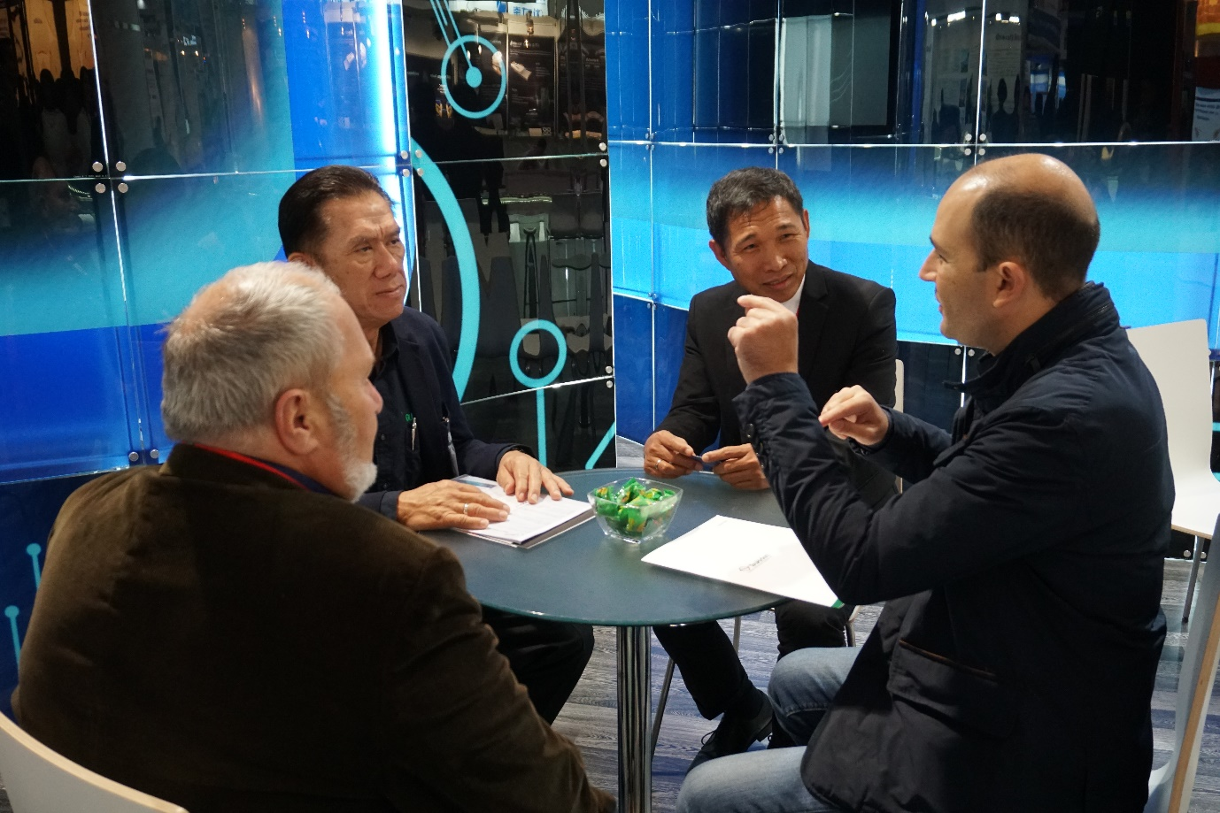
Business Meetings. Mr. Joey Palma of Global Circuit Sourcing Solutions and Edgardo Etac of Tsukiden Electronics Philippines met with foreign buyers in the Philippine pavilion to discuss possible areas of partnership in electronics services.

“With all the companies that participated already looking forward to the next Electronica, we are studying how we can capitalize on the market insight that we gathered in this event to give more boost to the Philippines in future export promotion activities,” Suaco-Juan said.

After the Philippines’ successful participation, several local companies have reached out to DTI-CITEM and signified their interest to join the next delegation in Electronica. These companies include GemPhil Technologies, Inc., Bell Electronics Corporation, and Fastech Synergy Philippines.

For their participation, Yongden Technology Corporation President Alex Sy expressed his gratitude to the government for its renewed support in promoting the electronics sector in international trade fairs. With the goal of business expansion and upgrading of facilities, Sy believed that his meeting with new clients in the show will help his firm materialize these goals.

Likewise, GCSS President Joey Palma said his company got “very good and serious trade inquiries” with the type of service they offer which includes manufacturing printed circuit boards (PCBs), plastic injection parts, precision and stamped metal parts, and cable and wire harnesses, among others.

Meanwhile, Elmer Lapeña, president and chief operating officer (COO) of Testech, Inc., emphasized that visibility is one major contributing factor in finding opportunities for his company, noting that “connection with new companies–visitors and exhibitors alike–is beneficial for the business especially in creating strategic partnerships and point of contact.

###

Ref. Ryanorlie Abeledo
Tel: 831-2201 local 253
Email: rabeledo@citem.com.ph
Twitter: @CITEMPh
Facebook: @DTI.CITEM

