Photo Release: Business

**Story in Photos: The Philippine delegation in Electronica 2018**

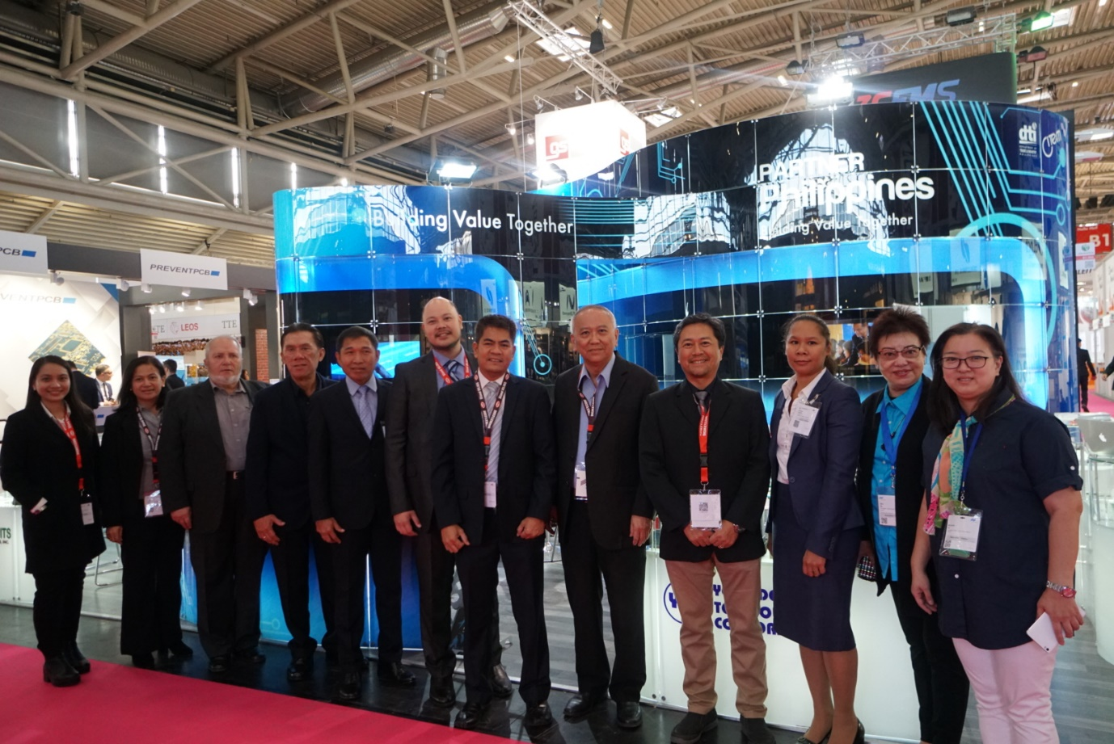

The Philippine delegation (from left to right): Giselle Erese of CITEM, Lanie Dormiendo of BOI - Europe, Middle East & Africa Division, Jurgen Manzzen of Global Circuit Sourcing Solutions, Kazuma Hanzawa of Tsukiden Electronics Philippines, Edgardo Etac of Tsukiden Electronics Philippines, Earl Qua of Ionics EMS, Inc., Val Carandang of Ionics EMS, Inc., Alex Sy of Yongden Technology, Elmer Lapeña of Testech Group, Mila Sy of Yongden Technology and Maribelle Sy of Yongden Technology.

Munich, Germany – The Philippine delegation welcomed foreign buyers and investors all over the world to the country’s pavilion in Electronica, one of the world’s leading international trade fairs for electronics, at the Hall B1 Booth 460, Messe Munchen in Munich, Germany.

With its recently held exhibit from November 13 to 16, the PartnerPhilippines pavilion showcased the country as a global powerhouse in electronics export, highlighting its robust manufacturing industry, state-of-the-art facilities, highly skilled and competitive workforce and growing components supply base, among other market advantages.

Participating companies under the PartnerPhilippines pavilion were Yongden Technology Corporation; Global Circuits Sourcing Solutions; Tsukiden Electronics Philippines, Inc.; Ionics EMS, Inc.; and Testech, Inc.

**PartnerPhilippines Pavilion Interactions**

Representatives of Philippine companies accommodated interested foreign buyers or investors who visited the PartnerPhilippines pavilion to get an overview on the lucrative trade and business opportunities available in the country.

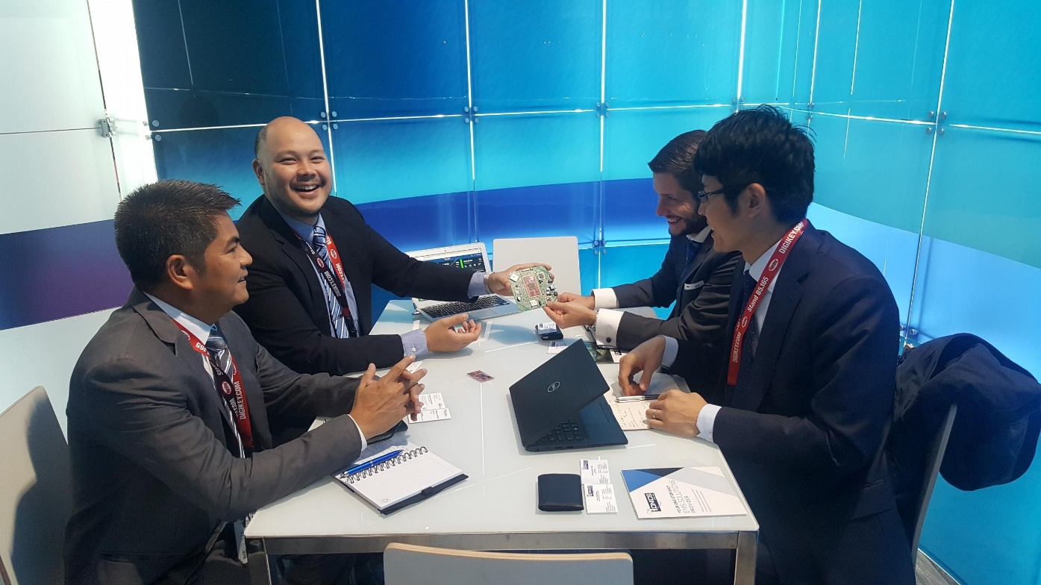

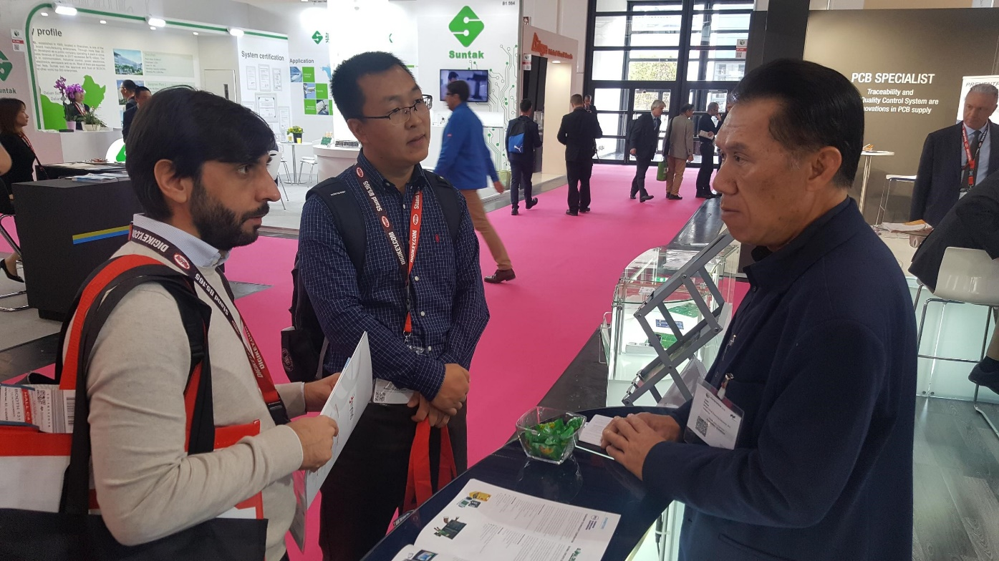

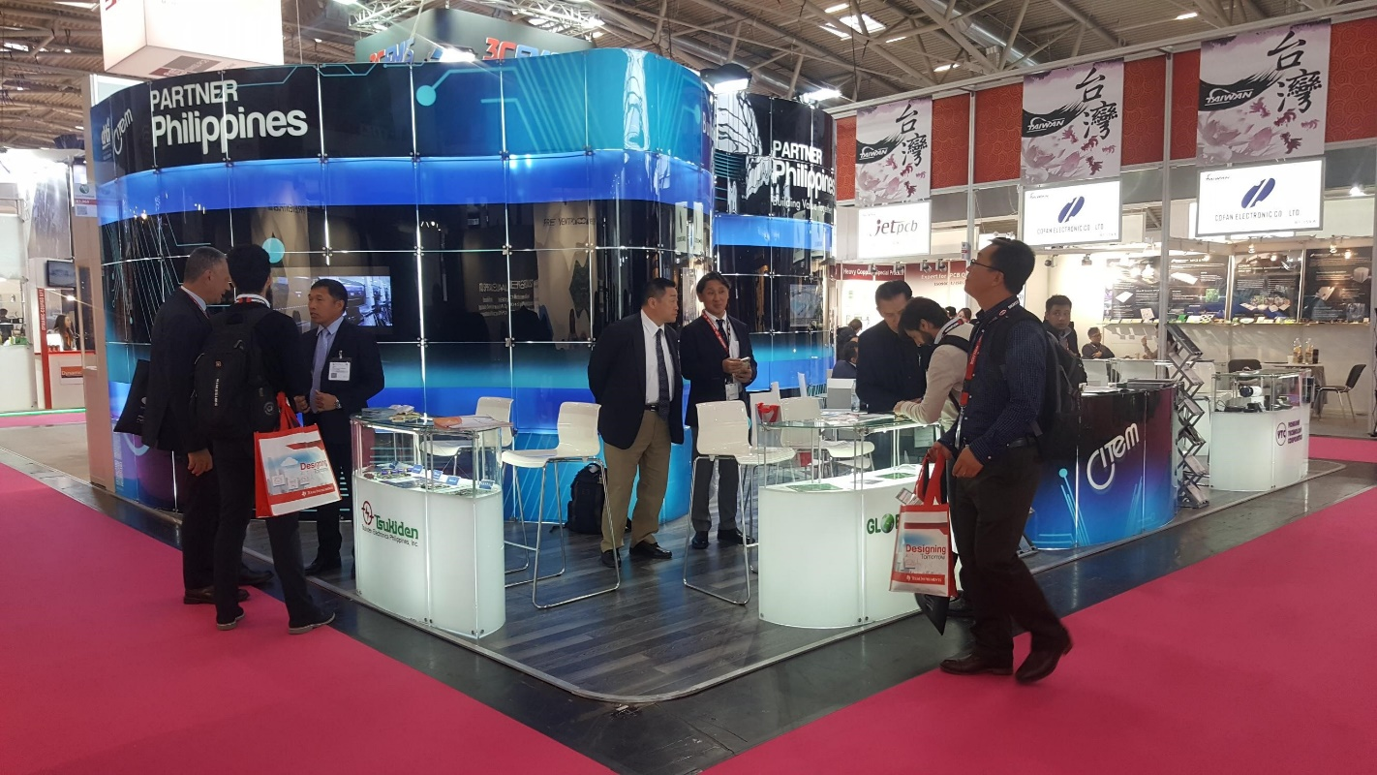

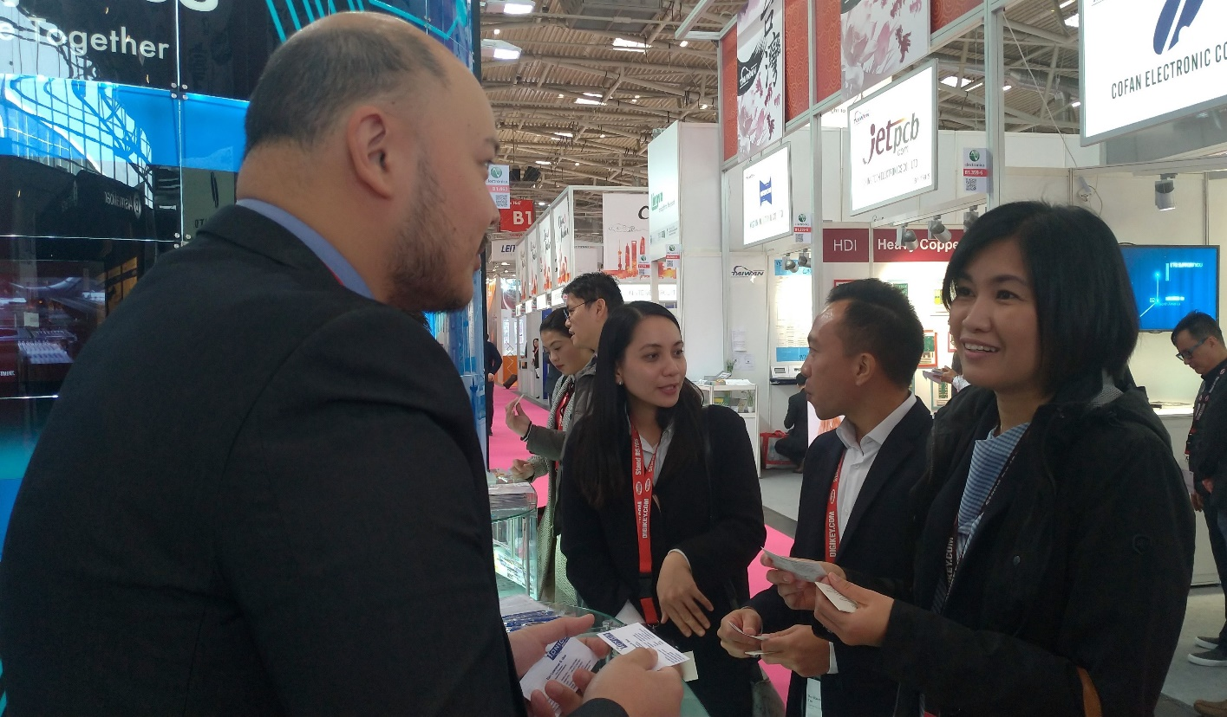

###

Ref. Ryanorlie Abeledo

Tel: 831-2201 local 253

Email: rabeledo@citem.com.ph

Twitter: @CITEMPh

Facebook: @DTI.CITEM