Press Release: Business

Five firms step up to represent PH at the world’s leading electronics trade fair in Germany

Published: Tuesday, November 9, 2018

- DTI-CITEM eyes to expand PH’s electronics exports thru Electronica 2018.
- Participating companies under the PartnerPhilippines pavilion are Yongden Technology Corporation; Global Circuits Sourcing Solutions; Tsukiden Electronics Philippines, Inc.; Ionics EMS, Inc.; and Testech, Inc.

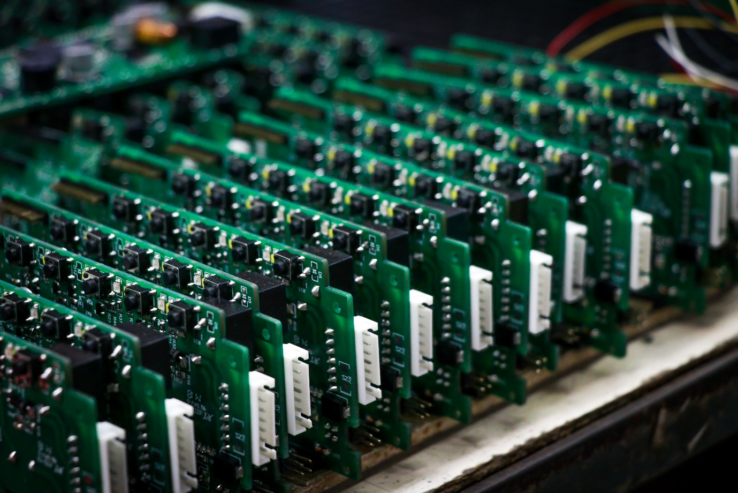
Printed circuit boards manufactured and assembled by Yongden Technology Corporation, one of the companies participating under the PartnerPhilippines pavilion in Electronica 2018.

Five electronic firms gear up to represent the country in its return to Electronica, one of the world’s leading international trade fairs for electronics, on November 13 to 16 at the Hall B1 Booth 460, Messe Munchen in Munich, Germany.

Led by the Department of Trade and Industry through the Center for International Trade Expositions and Missions (DTI-CITEM), five local electronics companies are set to bolster the Philippines’ export promotion and exhibit in Electronica 2018.

“Some of the country’s leading electronic manufacturing companies will be joining the Philippines’ comeback to Electronica after more than 20 years,” said DTI-CITEM Executive Director Pauline Suaco-Juan.

“The companies are eager to showcase their diverse portfolio and decades of experience in providing service to international clients as part of concerted efforts to promote the country’s robust manufacturing industry and strong export capability in the electronics global value chain (GVC),” she added.

Participating companies under the PartnerPhilippines pavilion are Yongden Technology Corporation; Global Circuits Sourcing Solutions; Tsukiden Electronics Philippines, Inc.; Ionics EMS, Inc.; and Testech, Inc.

Existing for more than 50 years, Electronica has become the world’s leading international trade fair for electronic components, systems, applications and other innovative solutions, such as smart homes and electronic cars.

On its previous edition in 2016, a total of 2,912 exhibitors from more than 50 countries gathered to network with almost 74,000 visitors and met with professionals from around the world.

Alex Sy, President of Yongden Technology Corporation, said that this participation is “a strategic move to promote the Philippines’ export capability in terms of original design manufacturing (ODM) and original equipment manufacturing (OEM).”

“As one of the exhibitors in CITEM’s past Electronica participation, this return to Germany also provides a great opportunity for Philippine companies to get inspiration and market insights, learn new trends, and sit down with business counterparts from across the globe,” said Sy.

Below are the five companies joining the Philippine delegation in Electronica 2018:

Yongden Technology Corporation

Incorporated in 1992, Yongden Technology Corporation has established itself as an export-competitive OEM and ODM with its strong R&D group and excellent manufacturing team.

In its more than 25 years in manufacturing, Yongden has always emphasized quality and reliability for its products and continues to provide excellent services according to the requirements of its customers. Starting from simple consumer products, the company now produces electronic equipment instrumentation and other technology-related products.

Global Circuits Sourcing Solutions

Global Circuits Sourcing Solutions (GCSS) is a Philippine manufacturer of printed circuit boards (PCB) with over 40 years of experience in electronics manufacturing.

The company can manufacture various sizes of PCB in volumes with its strategic partnerships with organizations and facilities in China, Taiwan, and other countries all over the world that have certifications for quality management system under U.L., ISO, QS, and TS16949. The companies they work with are also compliant with the Restriction of Hazardous Substances (ROHS) and the non-use of “conflict materials.”

Tsukiden Electronics Philippines Inc.

Tsukiden Electronics Philippines, Inc. is an electronic manufacturing service (EMS) provider founded in 1987 and has more than 30 years of experience in the Philippines. It is a subsidiary of Tsukiden Hong Kong Ltd. with affiliate companies in Japan.

The company's main services are PCB and chips on flex assembly, sub-system build assembly, complete box build assembly, rework and warranty repair. They have management certifications under ISO 9001, ISO 14001, OHSAS 18001, ISO 13485 and IATF 16949.

Ionics EMS Inc.

Ionics is one of the Philippines’ leading EMS providers that caters to global electronic firms, offering solutions such as manufacturing, product development and engineering services.

With over 40 years of experience in EMS, Ionics is considered the oldest and most experienced electronics manufacturing services provider in the Philippines, pioneering many “firsts” in the industry. Among these are being the first to shift to the PCB assembly and the first to start the flip chip technology in the country.

Testech Inc.

Testech Group is the preferred industrial process outsource solutions provider to the electronics and semiconductor industries. Their broad experience in various industries, technical expertise and operational excellence, enable them to drive productivity and profitability that have benefited their partners and clients through the years with the aim of bringing solutions to other industries as well.

##

CITEM, the export promotion arm of DTI, spearheads the efforts of the government in promoting the Philippines as a premier sourcing destination for export products and services.

The participation in Electronica is undertaken in cooperation with the Philippine Trade and Investment Center (PTIC) in Berlin, Bureau of Investment (BOI) and the Office of Senator Loren Legarda.

Visit citem.com.ph/electronica/ for more information on the Philippine participation.

Ref. Ryanorlie Abeledo
Tel: 831-2201 local 253
Email: rabeledo@citem.com.ph
Websites: citem.gov.ph
Twitter (@CitemPh)
Facebook (/dti.citem)

