PRESS RELEASE

PH eyes to expand electronics exports, investments at the world’s leading electronics trade fair in Germany
DTI-CITEM returns to Electronica as the country’s billion-dollar electronics industry booms
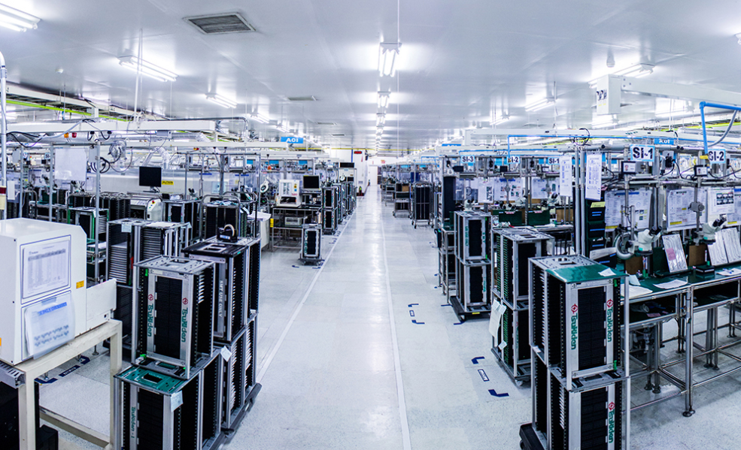
The manufacturing facility of Tsukiden Electronics Philippines Inc., one of the companies joining the delegation at Electronica 2018.

The Philippines will make a comeback to Electronica, one of the world’s leading international trade fair for the electronics, on November 13 to 16 in Munich, Germany, as part of the industry and government’s concerted efforts to promote its booming electronics sector.
The Department of Trade and Industry, through the Center for International Trade Expositions and Mission (DTI-CITEM), is set to present the country as a global powerhouse in electronics export, highlighting its robust manufacturing industry, state-of-the-art facilities, highly skilled and competitive workforce, and growing components supply base, among other market advantages.
“Through a country exhibit in Electronica, we will showcase the Philippines’ export-oriented electronics industry to thousands of buyers, investors, top executive and decision makers from all over the world,” said DTI-CITEM Executive Director Pauline Suaco-Juan.

“Part of our showcase is presenting the country’s enabling and growing business environment where global players map out long-term development plans as they manufacture high-quality products, conduct research and development (R&D), and provide logistical support and innovative inputs to clients worldwide,” she added.
Existing for more than 50 years, Electronica has become the world’s leading international trade fair for electronic components, systems, applications and other innovative solutions, such as smart homes and electronic cars.
On its 2016 edition, a total of 2,912 exhibitors from more than 50 countries gathered to network with almost 74,000 visitors and met with professionals from around the world.
DTI-CITEM Executive Director Pauline Suaco-Juan

Joining the country delegation are Philippine-based electronics companies and manufacturers with support from the Philippine Trade and Investment Center (PTIC), Bureau of Investment (BOI) and the Office of Senator Loren Legarda.
“Philippine companies can look for buyers or partners in Electronica while, at the same time, benchmark their products with other competitors and get first-hand market insights on the prevailing global demands and market trends,” Suaco-Juan noted.
Companies who have confirmed their participation are Yongden Technology Corporation, Global Circuits Sourcing Solutions, Tsukiden Electronics Philippines, Inc. and Ionics EMS, Inc.
Rising Electronics Exports
The Philippines is currently among the top 10 countries worldwide in terms of exporting electronic circuit components, contributing almost three percent in the global value chain (GVC).
“With electronics and electrical (E&E) product as its top export, the Philippines has already established itself in the global value chain as a strategic hub for sourcing, manufacturing, and other investment activities,” Suaco-Juan said.
For the first seven months of 2018, the Philippine electronics export grew by about 5.38% with $21.61 billion total sales compared to $20.43 billion last year, according to the Semiconductor and Electronics Industries in the Philippines Foundation, Inc. (SEIPI).

Of the country’s nine electronics product categories, six posted gains during the period, led by consumer electronics where exports rose 82.64% and generated $335.36 million worth of revenue.
Electronics also accounted for $3.27 billion or 56% of the $5.86 billion total Philippine exports in July.
Last year, the country’s electronics sector saw its first double-digit, year-to-year growth in history, recording an all-time high of 11 percent increase from 2016 to 2017.
In terms of electronics exports to EU, the Philippine electronics sector has also seen a major upswing, growing by about 16 percent. It generated €3.47 billion worth of export sales in 2017 as compared to €2.99 billion in 2016.
Among the top Philippine electronics export to EU in 2017 are electronic integrated circuits; electrical transformers and static converters; diodes, transistors and similar semiconductor devices, as well as photosensitive semiconductor devices; and discs, tapes, solid-state non-volatile storage devices, or “smart cards,” among other commodities.
According to SEIPI, the annual investment in the country’s electronics sector is expected to rise to $1.5 billion by 2020; $3 billion by 2025; and $5 billion by 2030.
By 2020, the Philippine electronics sector is also projected to employ a total of 5.5 million professionals and laborers, up from an s estimated current levels of 3.2 million in 2017.
Likewise, the country’s electronic sector expects to see at least $50 billion worth of annual electronics export sales in 2030, growing at about 6 percent annually.
##
Ref. Ryanorlie Abeledo
Tel: 831-2201 local 253
Email: rabeledo@citem.com.ph
Websites: citem.gov.ph
Twitter (@CitemPh)
Facebook (/dti.citem)

