**PRESS RELEASE**

**PH eyes automotive export expansion, benchmarks at world’s biggest automotive aftermarket event in Germany**

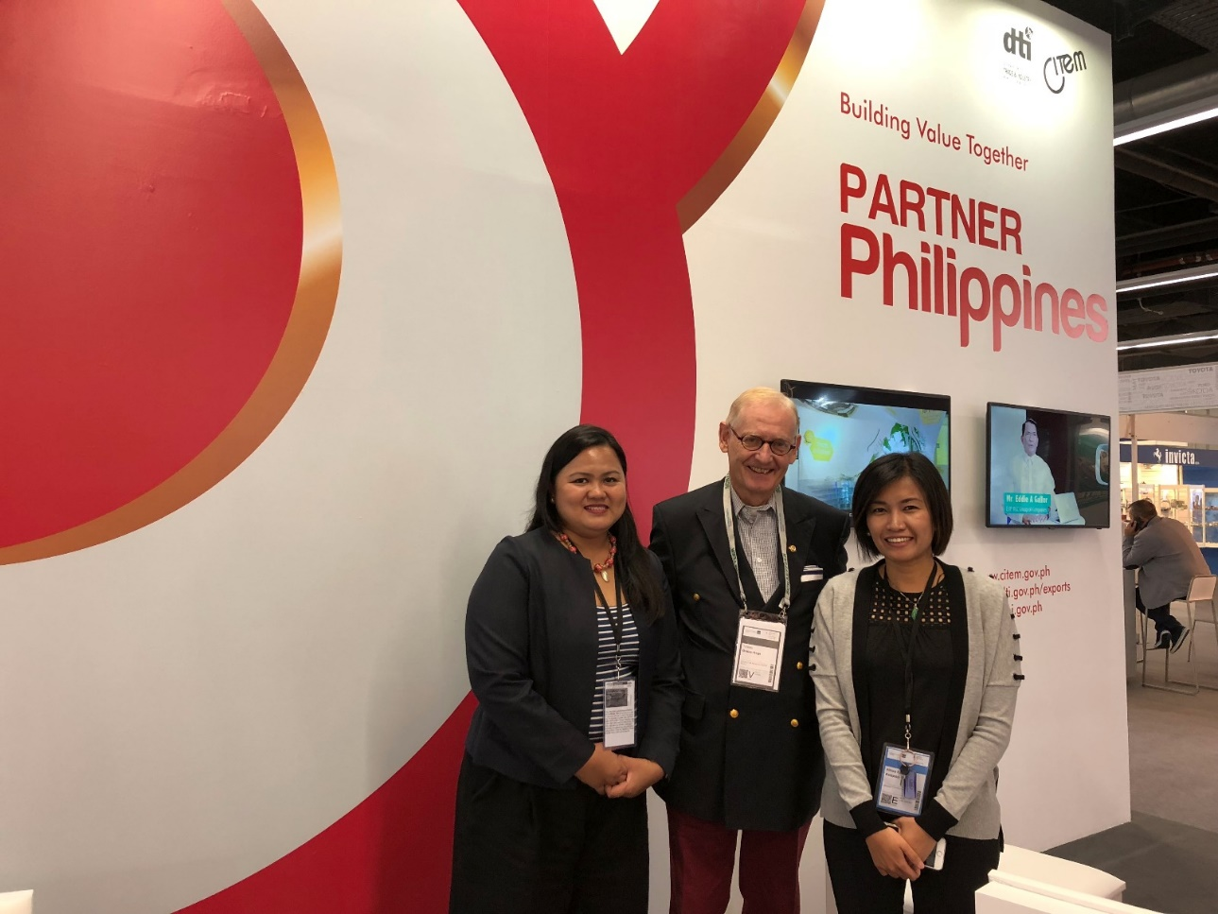

All Smiles: DTI-CITEM OIC-Division Chief Katrina Pineda and PTIC-Berlin Commercial Attache Althea Karen Antonio posed with Honorary Consul Torsten Griess-Nega after discussing the trade and investment potential of the Philippine automotive market.

With burgeoning automotive industry, the Philippines set its sights on expanding its automotive exports in its participation in Automechanika Frankfurt, the world’s biggest automotive aftermarket event, last September 11-15 at the Messe Frankfurt in Frankfurt, Germany.

Under the banner of Partner Philippines, the country’s delegation returned to Automechanika after 22 years to exhibit the country’s strategic advantages and new trade opportunities in the global automotive value chain.

The delegation was led by the Department of Trade and Industry through the Center for International Trade Expositions and Missions (DTI-CITEM). It was supported by the DTI’s Export Marketing Bureau (EMB), Philippine Trade Investment Center (PTIC) in Berlin, Foreign Trade Services Corps (FTSC), the Office of Senator Loren Legarda, business support organizations (BSOs) and other private partners.

Automechanika is the world’s leading trade fair for the automotive aftermarket industry organized by the world’s largest trade fair organizer Messe Frankfurt Group. Held biennially, it is participated in by almost 5,000 exhibitors and over 130,000 visitors from Germany and across the world.

“Automechanika served as the perfect platform in presenting the Philippines’ strategic advantages and industry capabilities to further cement the country’s status as a fast-rising automotive manufacturing hub in Southeast Asia,” said DTI-CITEM Executive Director Pauline Suaco-Juan.

“The delegation also promoted Philippine companies that have strong export potential to buyers and investors who visited the Partner Philippines pavilion,” Suaco-Juan added.

Over 100 buyers and investors expressed keen interest in working with the Philippines. Their inquiries include looking for manufacturers of car seat, automotive electronics, and supplier of water pumps and batteries. There are also those who look for available investment packages like areas of possible cooperation to put up a distribution center or manufacturing facility in the Philippines to service the Southeast Asian market.

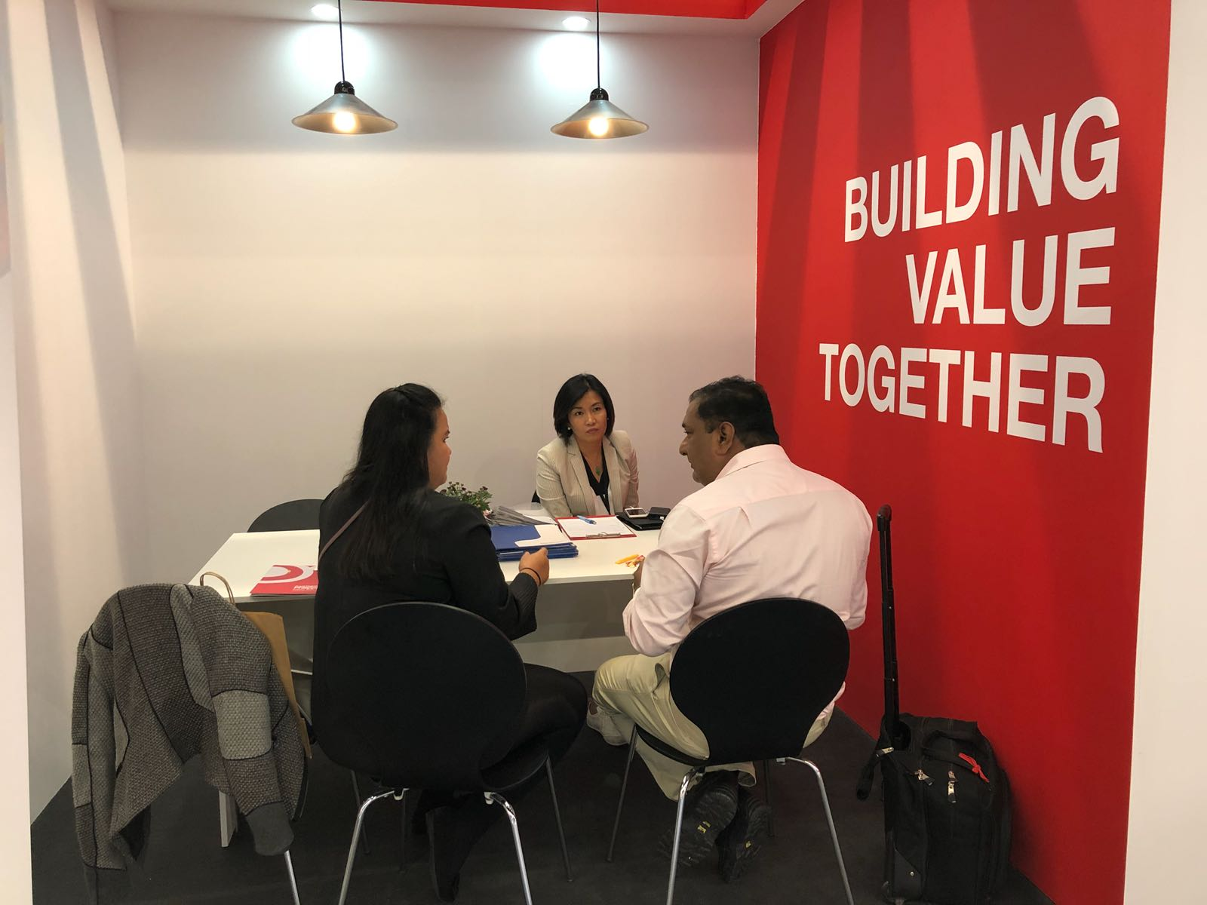

Philippine representatives briefed an interested buyer at the Partner Philippines pavilion in Automechanika Frankfurt at the Messe Frankfurt in Frankfurt, Germany.

Companies promoted by the Philippines include Integrated Micro-electronics, Inc. (IMI), URATEX - Bus Seats, Roberts Automotive and Industrial Parts Manufacturing Corporation, Tri-R Allied Industries, Inc., JTEKT Philippines Corporation, Tsukiden, BF Metal and P & R Parts & Machineries, Inc.

CITEM and PTIC-Berlin also attended the business-matching activities organized by the Europe Enterprise Network (EEN) and the German Chamber of Commerce (IHK) Automotive-Cluster Rhein, Main, Neckar.

“Participation in trade fairs like Automechanika is a much-needed boost to globalize our local industry manufacturers and help streamline the transformation of the Philippine industrial sector by capitalizing on our market edge,” shared Suaco-Juan.

The country’s strength in the automotive industry is in the production of electronic components as around two-thirds of its US$3.98 billion exports in 2014 fall under one of these categories. Six of the country’s 10 largest exporters are wire harness companies.

Wire harness, which direct the flow of current and electronic signals throughout the vehicle, is of growing importance as evident in the increase of production of vehicle electronic parts. Exports of wire harnesses increased by 129% from 2007 to 2014, making the Philippines the world’s fourth largest exporter of wire harnesses in those years.

On the other hand, the second largest export category consists of wheel and tire assemblies, drive trains and vibration controls. The third largest export category—gearboxes or transmissions—has been demonstrating consistent growth with now, at least, four companies actively producing it.

“For our next step, we look to aggressively capitalize on our strength in manufacturing electronic parts and wiring harnesses as we make our headway in another major fair in Germany which is Electronica,” Suaco-Juan noted.

Electronica will be held on 13-16 November 2018 at the Messe München Trade Fair Center, Munich, Germany. Existing for more than 50 years, it has become the world’s leading international trade fair for electronic components, systems, applications and other innovative solutions, such as smart homes and electronic cars.

On its 2016 edition, a total of 2,912 exhibitors from more than 50 countries gathered to network with almost 74,000 visitors and dialogued with professionals from around the world.

For Electronica, DTI-CITEM still welcomes interested companies that produce or service semiconductors and other electronic components. Also welcome to participate are manufacturers of electronic data processing equipment, office equipment, telecommunications, consumer electronics, communications and radar, control and instrumentation, medical and industrial, automotive electronics, and solar/photovoltaics.

Interested participants who want to join Electronica can contact Ms Giselle Erese at 831-2201 loc. 322 or via e-mail at [gaerese@citem.com.ph](mailto:gaerese@citem.com.ph).

##

Ref. Luz Soriano

Tel: 831-2201 local 253

Email: [lsoriano@citem.com.ph](mailto:lsoriano@citem.com.ph)

Websites: citem.gov.ph

Twitter (@CitemPh)

Facebook (/dti.citem)