CITEM – PRESS RELEASE Ref: Luz Soriano
Tel: 831-2201 local 253
Email: lsoriano@citem.com.ph Websites: citem.gov.ph
Twitter (@CitemPh)
Facebook (/dti.citem)

PH spearheads entry to global electronics, automotive markets through int’l trade fairs in Germany
DTI-CITEM invites local firms to exhibit electronica and Automechanika
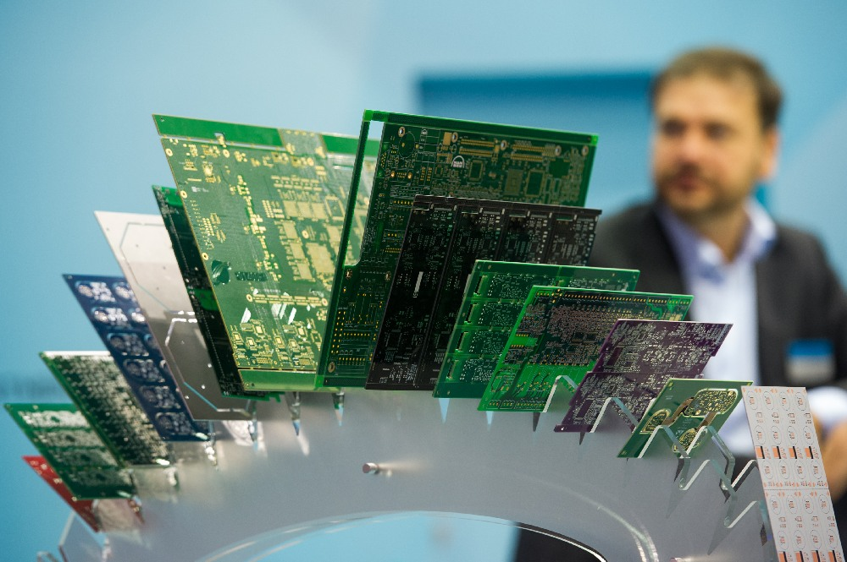
Semiconductor chips displayed at electronica 2016. Photo by GETA Ltd.
The Philippines is expanding its promotion drive to non‐traditional global markets as the Department of Trade and Industry, through the Center for International Trade Expositions and Missions (DTI-CITEM), looks to bring local companies in the world’s biggest fairs in automotive and electronics in Germany.
“We are inviting the country’s electronics and automotive companies to join us and explore the global market to promote the export and investment opportunities in the Philippines through trade exhibits abroad,” said DTI Undersecretary for Trade and Investments Promotion Group (TIPG) and concurrently CITEM Officer-in-charge (OIC) Nora K. Terrado.
“For this year, we are set to bring a country delegation in two of the world’s biggest industrial events in electronics and automotive both held in Germany with the goal of creating more business opportunities to companies in non-traditional sectors, diversifying our export promotion and globalizing our local industry players,” added Terrado.
DTI Undersecretary Nora K. Terrado.
Automechanika and electronica
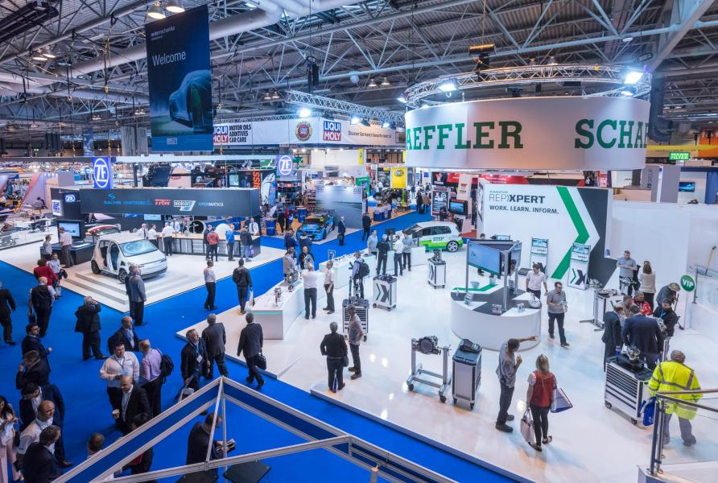
A look at Automechanika 2016. Photo by Autobiz.
From September 11 to 15, CITEM is inviting local companies to join the Philippine delegation in Automechanika inn Frankfurt, Germany.
It is world’s leading trade fair for the automotive aftermarket industry that exhibits a wide range of products including, but not limited to: parts & components, electronics & systems, repair & maintenance, accessories & customizing, car wash, care, & reconditioning, (dealer & workshop management, and alternative drive systems & digital solutions (tomorrow’s service & mobility).
DTI-CITEM last participated in Automechanika in 1996 with 10 companies. Some of the products showcased were battery clamps, alloy wheels, seat covers and other interior upholstery and parts, radiators, leaf springs, and oil lubricants.
For Automechanika 2018, CITEM is inviting automotive aftermarket companies that produce and services parts and components, electronic and systems, and accessories manufacturing companies, among others.
“The primary objective of returning to Automechanika Frankfurt is to make Philippines’ presence be felt again and create awareness globally on the extent of industry capabilities of Philippine automotive companies,” said Terrado.
Meanwhile, Philippine companies may also join on November 13 to 16 in electronica in Munich, Germany. Existing for more than 50 years, it has become the world’s leading international trade fair for electronic components, systems, applications and solutions make new developments, such as smart homes and connected cars possible in the first place.
On its 2016 edition, a total of 2,912 exhibitors from more than 50 countries gathered to network with almost 74,000 visitors and dialog with professionals from around the world. CITEM’s fourth and last participation in electronica was in 1998.
For electronica, CITEM is looking for companies that produce or service semiconductors and other components, electronics data processing equipment, office equipment, telecommunications, consumer electronics, communications and radar, control and instrumentation, medical and industrial, automotive electronics, and solar/photovoltaics.

“After consultations from industry players and public partners, we have determined that the time is ripe for the Philippines to once again make a comeback in these trade events which we have not participated in for more than two decades,” said Terrado.

“Through a synergy among stakeholders, we hope to seal export deals and partnerships with international buyers and investors to mobilize much‐needed funding and technology to our local players,” explained Terrado. “Germany is a strategic location to meet such partners since it has been a premier hub for various industry events.”
According to the Association of the German Trade Fair Industry (AUMA), two-thirds of the world’s leading trade fairs take place in Germany, hosting around 150 international trade fairs each year for 180,000 exhibitors and 10 million visitors.
History, geography and economics have made Germany a global leader in a centuries-old method of matching buyers to sellers, according to news agency Handelsblatt Global.
Diversifying and developing PH non-traditional exports
“Promoting local players in developing industry sectors is part of DTI’s current agenda to expand and develop the country’s export portfolio and make its non-traditional exports get a bigger share in the global value chain,” said Terrado.
DTI's export diversification thrust is in line with recommendations of World Trade Organization (WTO) in recently released report on “Mainstreaming trade to attain the SDGs” as part of keeping up with the 2030 Agenda for Sustainable Development and its Sustainable Development Goals (SDGs).
According to WTO, diversification into other exports should be high on the list of priorities, therefore, for countries dependent on commodity exports.
The global trade regulator noted that there is an “urgent need to adapt to changing environmental conditions makes trade diversification even more important.”
“To assist their diversification efforts, these countries need predictable market access conditions and capacity building,” reads the report.
“This will help in achieving decent work and economic growth, fostering industrialization, innovation and infrastructure, reducing inequalities among countries and increasing participation in world trade,” the report added.
Interested exhibitors for Automechanika may contact Ms. Katrina Ledesma at 831-2201 loc. 227 or via e-mail at katlesdesma@citem.com.ph. Those interested in electronica may contact Ms. Giselle Erese at 831-2201 loc. 322 or via e-mail at gaerese@citem.com.ph.
…
CITEM, the export promotion arm of DTI, spearheads the efforts of the government in promoting the Philippines as a premier sourcing destination for export products and services.
The participation in Automechanika and electronica is undertaken in cooperation with Export Marketing Bureau (EMB), Philippine Trade and Investment Center (PTIC) in Berlin, Foreign Trade Services Corps (FTSC), German-Philippines Chamber of Commerce and Industry (GPCCI), concerned country embassies, business support organizations (BSOs) and other private partners.
For more information on its services and events, please log on to http://www.citem.gov.ph.

